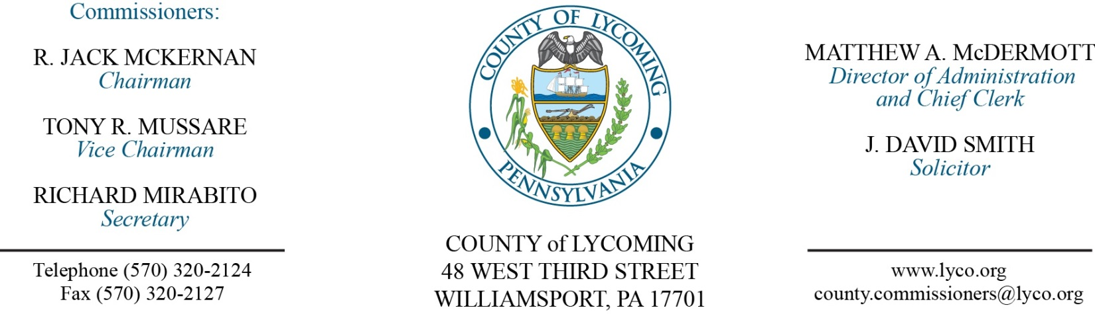
Commissioners’ Meeting Agenda
October 20, 2016

Opening Prayer

Pledge to the Flag

1.0 OPERATIONS

1.1 Convene Commissioners’ meeting.

1.2 Approve the minutes of the previous meetings.

1.3 Receive public comments (agenda items only).

2.0 ACTION ITEMS

2.1 Adopt resolution 2016-22 for transfer of vehicle to Lycoming County Recreation Authority. (Mya Toon)

2.2 Approve quote from Watertronics for vertical turbine proposal for WDGC in the amount of $18,100. (Mya Toon)

2.3 Approve quote from Watertronics for control panel proposal for WDGC in the amount of $54,727. (Mya Toon)

2.4 Approve 2016 nutrient trading contract with NGC Industries. (Megan Lehman)

2.5 Approve amendment 2 to agreement with Lycoming County Water & Sewer Authority for Fairfield Water Storage Tank. (Kurt Hausammann)

2.6 Approve child welfare services contract with KidsPeace National Centers, Inc. for foster care and residential care services at per diems ranging from $53.58/day to $111.31/day for the period July 1, 2015 through June 30, 2016. (Mark Egly)

2.7 Approve the following Human Services Development Fund contracts for the period July 1, 2016 to June 30, 2017: (Mark Egly)
• Confer Home Health Services, LLC for adult homemaker services in the amount of $20,000.
• Favors Forward for Information and Referral services in the amount of $3,000.
• Jersey Shore Summer Recreation, Inc., for life skills educational services in the amount of $4,000.
• American Rescue Workers for emergency shelter services in the amount of $10,000.
• YWCA, Liberty House for emergency shelter services in the amount of $10,000.
• Community Alliance for Progressive Positive Action, CAPPA for life skills educational services in the amount of $16,000.
• Firetree Place for life skills educational services in the amount of $16,000.

2.8 Approve equipment rental agreement with Cleveland Brothers Equipment Company Inc. for Cat. Generator. (Jason Yorks)

2.9 Approve amendment 2 to agreement with WSP USA Corporation for aerial mapping services. (Jason Yorks)

2.10 Approve professional service agreement with George Jr. Republic for Juvenile Probation Office. (Ed Robbins)

2.11 Approve professional service agreement with Cornell Abraxas for Juvenile Probation Office. (Ed Robbins)

2.12 Approve professional service agreement with BSI for Juvenile Probation Office. (Ed Robbins)

2.13 Approve professional service agreement with Justice Works for Juvenile Probation Office. (Ed Robbins)

2.14 Approve the following personnel actions:
RMS – Transfer Station – Donald H. Dymeck, Jr. as full time replacement Truck Driver – Pay grade 6 - $19.216071/hour effective 10/23/16.
RMS – Business Office – reclassification of Bonnie A. Fink to full time Business Manager – Pay grade 11- $76,837.62/annually effective 12/18/16 (per reorganization in 2015/involuntary reclassification).
RMS – Support Services – reclassification of Richard L. Shief to full time Operations & Support services clerk – Pay grade 5 - $19.88/hour effective 12/18/16 (per reorganization in 2015/involuntary reclassification).

2.15 Approve agreement with Williamsport Municipal Airport Authority for airport terminal funding.
Recess Commissioners’ Meeting

4.0 BOARD of ASSESSMENT REVISION

4.1 Convene Board of Assessment Revision.

4.2 Approve the following real estate exemption requests:
PARCEL | NAME | SITE LOCATION | REASON FOR EXEMPTION
28-001-509 | McHenry Twp | Rt 414 Hwy | Township parking & dumpster housing
25-427-123.B | Limestone Twp | Rt 44 Hwy | Little League Baseball Fields
40-393-137 | Muncy Borough | 117 Old Glade Run Rd | Storage of borough equipment
43-014-180 | Memorial Baptist Church | 40 Hillview Ave | New Church
71-002-450 | Community Action Realty | 2140 Boyd St | Leased bldg to Step
70-002-208 | St Paul Calvary United | 1419 Memorial Ave | Garage used for church storage
24-002-204 | Oasis of Hope Ministries | 265 Slacks Run Rd | Building will be used for victims of sex trafficking

4.3 Deny the following real estate exemption requests:
PARCEL | NAME | SITE LOCATION | REASON FOR EXEMPTION
73-007-413 | Penn College of Tech | 508 Fifth Ave | Empty Lot
70-006-302 | St Paul Calvary United | 1437 Memorial Ave | Vacant lot used periodically for outdoor worship services
70-006-301 | St Paul Calvary United | 1435 Memorial Ave | Vacant lot used periodically for outdoor worship services
73-006-222 | Family Promise of Lyc Cty | 817 Park Place | Transitional Housing

4.4 Adjourn Board of Assessment Revision.

Reconvene Commissioners’ Meeting

5.0 REPORTS/INFORMATION ITEMS

5.1 Lycoming County RMS is requesting bids for 4-Used Dry Cargo Van Trailers. (Jason Yorks)

5.2 Presentation recognizing ALICE trainers.

6.0 COMMISSIONER COMMENT:

7.0 PUBLIC COMMENT:

8.0 NEXT REGULARLY SCHEDULED MEETING: Planning Session on Tuesday, October 25, 2016.

9.0 ADJOURN COMMISSIONERS’ MEETING.

